ACTIVITIES

CONFERENCES, SEMINARS AND OTHER EVENTS

- Official launching of the Argentine-American Dialogue Foundation
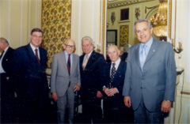
The Argentine American Dialogue was officially presented on September the 24, 2004.
The speakers were: Dr. Oscar Camilión, the President of the Advisory Board, the Honorable Lyle Williams, and our President, Dr. Luis Ruvira. Dr. Camilión and the Hon. Lyle Williams spoke about the current state of the bilateral relations and the future role of the Foundation.
The event had a very large attendance, that surpassed the expectations, and numerous personalities from the business and political world were present throughout the event.

- Conference: “The Political Situation and the presidential election in the United States”
Speaker: Honorable Lyle Williams, former congressman and president of the American branch of the Argentine American Dialogue (Washington, DC).
Place: Club de Harvard.
September 2004.

- Conference: “The AAD and the Education in the present context”
Speaker: Honorable Lyle Williams.
Place: Rafaela, Santa Fe.
September 2004.

- Conference: “Development of Anti-Terrorist policies in the U.S. before and after September 11”
Speaker: Prof. Yonah Alexander, Senior Fellow and Director of the Center for International Studies on Terrorism of the Potomac Institute for Policy Studies.
Place: Universidad de Ciencias Empresariales y Sociales (UCES).
October 5, 2004.

- Lunch: “International Security: Strategies and Perspective against the Terrorism”
Speaker: Prof. Yonah Alexander, Senior Fellow and Director of the Center for International Studies on Terrorism of the Potomac Institute for Policy Studies.
Place: American Club.
October 6, 2004.

- Conference: “The role of the Supreme Court”
Speaker: Judge Peter J. Messitte, Judge of the District of Maryland, United States.
Place: American Club.
November 2004.

- Conference: “Trade Agreements and Argentina”
Speaker: Prof. Jon Huenemann, Fleishman-Hillard Government Relations Consultant (Washington DC), and former Assistant U.S. Trade Representative in the Executive Office of the President with responsibilities in the Americas.
Place: Universidad de Ciencias Empresariales y Sociales (UCES)

- Videoconference: “The Situation in Latin America and the United States”
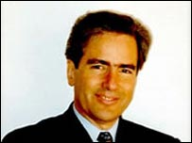
Speaker: Dr. Arturo Valenzuela, Center for Latin American Studies of the Georgetown University. Former Undersecretary for Latin-American Affairs during the first presidency of Bill Clinton.
Place: U.S. Embassy in Argentina.
April 29, 2005

- Conference: “The relations between Argentina and the United States”
Speakers: Dr. Andrés Cisneros and Sergio Berensztein
Place: Universidad de Ciencias Empresariales y Sociales (UCES)
June 15, 2005

- Lunch: “Financing of the Terrorism”
Speaker: Special Agent David Strange (FBI Supervisor).
Place: American Club.
June 21, 2005.

- Breakfast: “Security and Planning”
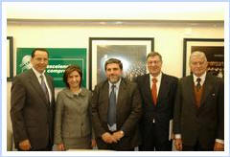
Speaker: Edward Garza, former mayor of San Antonio, Texas.
Place: Universidad de Ciencias Empresariales y Sociales (UCES)
July 6, 2005.

- Lunch: “political parties strengthening”
Speaker: Ted Jelen, professor of Political Science (Nevada University).
Place: American Club.
August 11, 2005.

- Lunch: “The Business and the Politics”
Speaker: Dr. Frederik Woodbridge, specialist in International Business Rights.
Place: American Club.
September 20, 2005.

- Conference: “The Business and the Politics”
Speaker: Dr. Frederick Woodbridge, specialist in International Business Rights.
Place: Universidad de Ciencias Empresariales y Sociales (UCES)
September 22, 2005.

- Debate “The role of the young people in the actual policy”
Speakers, and political parties that each one represented:
Agüero, Juan Manuel - Unión por Todos.
Caucino, Mariano - Partido Justicialista.
Ferraro, Maximiliano – Acción para una República de Iguales (ARI).
Garberi, Juan – Movimiento de Integración y Desarrollo (MID).
Grillo, Alejandro – Unión Cívica Radical (UCR).
Gutiérrez, Walter – Unión del Centro Democrático (UCEDE).
Luna, Mariano - Recrear.
Orensanz, Mariana - Compromiso para el Cambio.
Pereyra, Gonzalo - Partido Federal.
Trotta, Nicolás - Frente para la Victoria.
Co organized by the Argentine American Dialogue and the PENT Foundation
Place: PENT Foundation
Date: October 6, 2005

- Annual Cocktail of the Argentine American Dialogue
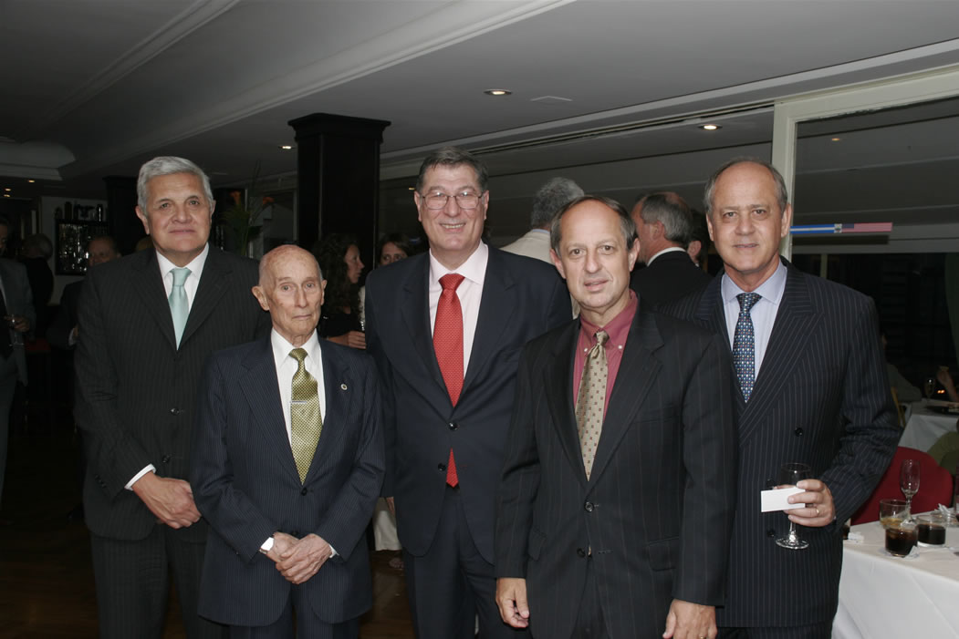
Speakers: Ambassador Lino Gutierrez and Dr. Luis Ruvira.
Place: American Club.
December 13, 2005

- Visit of Dr. Dennis Miller (former U.S. Department of Energy)
Meetings with congressmen, mayors, authorities of CARI (Argentine Council for International Relations), CEAMSE (waste management), CONEA (Atomic Energy National Commission), UNLA (Lanús National University), etc.
March 3-31, 2006

- Visit of the Judge Christine Odell Cook Miller (United States Court of Federal Claims)
Meetings with members of the Supreme Court, Federal Judges, ICANA (Argentine American Cultural Institute), Embassy of the United States of America, etc.
March 27-31, 2006

- “The Need to create an Hemispheric Cooperation on Security”
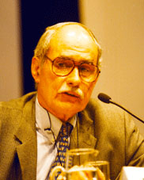
Speaker: Dr. David Scott Palmer (International Relations and Political Science professor, Boston University, Massachusetts).
Place: Universidad de Belgrano.
April 10, 2006

- Lunch: “The Hemispheric Cooperation in Security”
Speaker: Dr. David Scott Palmer (International Relations and Political Science professor, Boston University, Massachusetts).
Place: American Club.
April 10, 2006

- Visit, with the Dallas University, to the Central Bank of the Argentine Republic
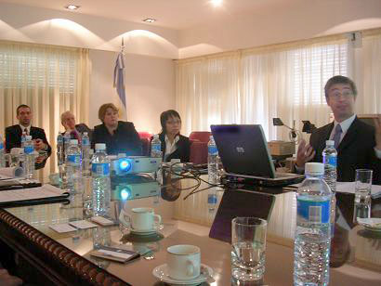
Speaker Fernando Avalos, Monetary and Financial Development Manager of the Central Bank.
Place: Central Bank of the Argentine Republic.
April 26, 2006

- Lunch: “The rol of the NGOs and the civil participation to secure the transparency in the local, state and federal government of the United Stated”
Speaker: Dr. Thomas Devine, Legal Director of the Government Accountability Project.
Place: American Club.
April 26, 2006

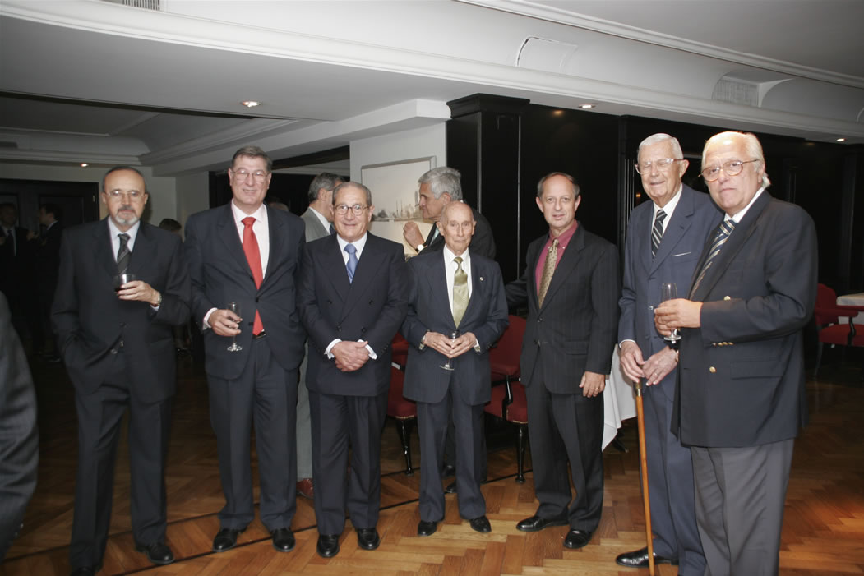
- Cocktail in honor of the Ambassador Lino Gutiérrez and his Wife
Speakers: Ambassador Lino Gutiérrez and authorities from the Argentine American Dialogue, American Club, The American Women's Club, The American Society of the River Plate and the Center of American Studies.
Place: American Club.
June 9, 2006

- Conference and Lunch on the subject “Race and Immigration”
Speaker: Dr. Mitchell Rice
Place: Universidad de Belgrano and American Club
August 14, 2006

- Conference on “Investment Strategies for Municipalities”
Speaker: Mr. Carlos Valderrama, Director of Latin American Operations at the law firm of Carlsmith Ball LLP
Place: Universidad de Belgrano.
September 1st, 2006

- Conference and Lunch on “Latin America Policies toward China and Impact on US Interests”
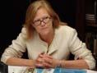
Speaker: Mrs. Jane Skanderup, Senior Associate of the Pacific Forum of International the Strategic Training Center (CSIS).
Place: Argentine National Congress and American Club.
September 13, 2006

- Regional Forum on International Security and Organized Crime
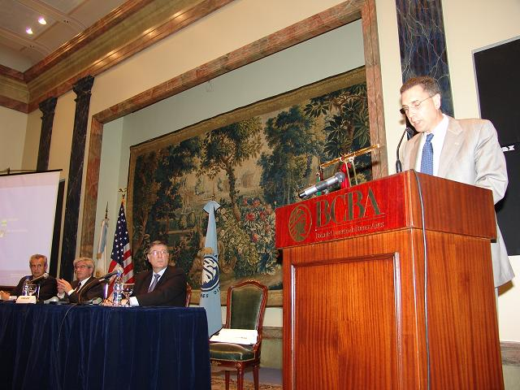
Speakers: authorities and specialist from Argentina, United States, Brazil and Paraguay.
Place: Buenos Aires Stock Exchange
September 18, 2006

- “The U.S. Mid-Term Elections”, Digital Video Conference
Speaker: Antonio Gonzalez, President of the Southwest Voter Registration Education Project (SVREP).
Place: U.S. Embassy in Buenos Aires.
September 26, 2006

- “The Importance of Free Trade”
Speaker: Ambassador Myles Frechette, former President and CEO of the Council of the Americas and former Assistant U.S. Trade Representative for Latin America.
Place: American Club, CARI (Argentine Council for International Relations), Enterprise Managers Association and the National Senate.
December 4, 5 and 6, 2006.

- “Energy Cooperation in the Western Hemisphere: Benefits and Obstacles”
Speaker: Dr. Sidney Weintraub, William E. Simon Chair in Political Economy at CSIS. Professor emeritus at the Lyndon B. Johnson School of Public Affairs of the University of Texas at Austin. Former deputy assistant secretary of state for international finance and development, and assistant administrator of the U.S. Agency for International Development.
Place: Ramella Hall, in the Senators Chambers Annex of the H. Congress of the Nation.
December 12, 2006.

- Book Presentation: “Ronald Reagan - Successes and Controversies”
Speaker: Marcelo Lascano, Dr. in Law and Social Sciences, Postgrade in Monetary and Banking Economy, Professor in the Faculty of Economic Sciences (UBA), former External Consultant of the IMF, former Undersecretary of Finance of the Nation, former Director of the BAPRO (Buenos Aires Province Bank), former Economic Adviser of the UIA (Argentine Industrial Union), author of 20 Books of Economy, Finances and Politics.
Commentators: Dr Adalberto Rodriguez Giavarini (Vice-president CARI), Luis Ruvira (President AAD) and Dr Rogelio Alonso (President Agora, Centro de Estudios Internationales).
Place: Argentine Council for International Relations
December 19, 2006

- “The value of strong institutions in a Democracy”
Speaker: Professor Strom C. Thacker, Director of Latin American Studies Program and Associate Professor of International Relations of the Boston University.
Place: American Club
March 13, 2007

- “International Trade in the XXI Century”
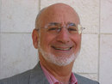
Speaker: Dr. Richard Feinberg. Director of the Asia Pacific Economic Cooperation (APEC) Study Center, and co-director of the Leadership Council on Inter-American Summitry. Former Special Assistant to President Clinton for National Security Affairs and senior director of the National Security Council's (NSC) Office of Inter-American Affairs. Former President of the Inter-American Dialogue.
Place: American Club and Argentine Council for International Relations (CARI)
March 19 and 20, 2007

- “The Importance of the Social Corporate Responsibility”
Speaker: Dr. Phil Rudolph. Vice-president of the Ethical Leadership Group in St. Charles (Illinois), former vice-president of McDonalds.
Place: American Club
March 28, 2007

- “Labor and Migratory Law in the United States”
Speakers: Dr. Salomon Chiquiar-Rabinovich, associate lawyer of Seyfarth Shaw LLP, Deputy President of the Hispanic National Bar Association (Region I- New England) and President of the New England-Latin America Business Council; and Dr. Eduardo Viñales, Senior Partner of Funes de Rioja Law firm.
Places: Delegation of Argentine Jewish Associations, University of Bologna, the Bar Association of the City of Buenos Aires, American Club, Argentine Industrial Union and Publishing house “La Ley”.
June 11 to 14, 2007.

- “Day of Independences”
Speaker: Ambassador Anthony Wayne, representative of the United States in Argentina.
Place: American Club
July 5, 2007

- “Civil Military Relations in a Democracy”
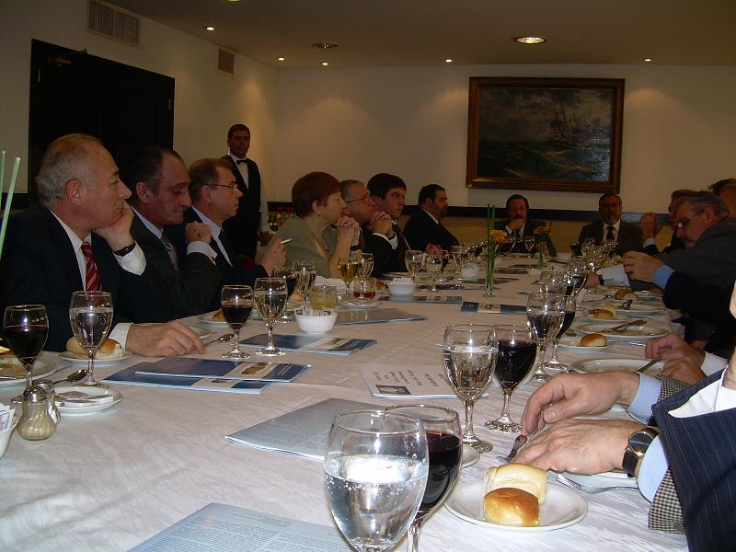
Speaker: Major General Richard B. Goetze, Jr., USAF (Ret.). Former Vice Director of the Joint Chiefs of Staff, former President of the College of Aeronautics in New York City, Deputy Program Manager for Latin America of the Center for Civil–Military Relations (CCMR) in Monterrey, California.
Place: American Club
August 9, 2007

- “Separation of Powers and Intellectual Property”
Speaker: Honorable Judge Margaret McKeown. United States Court of Appeals for the Ninth Circuit. Chair of the American Bar Association (ABA) Committee on Federal Judicial Improvements.
Place: American Club
November 21, 2007

- “Multiculturalism”
Speaker: Dr Mitchell F. Rice, Director of the Institute of Racial and Ethnic Studies, and Professor of Political Science in the University from Texas To & M.
Place: American Embassy in Buenos Aires
March 6, 2008

- “Management of public policies and NGO's”
Speaker: Peter Shiras, vice president - employment at the International Youth Foundation (IYF).
Place: American Club
April 9th, 2008

- “The Globalization and its impact in the society, government and companies”
Speaker: Dr. Harry Harris, President of Global Management Associates.
Place: American Club
April 29th, 2008

- “US presidential elections”
Speaker: Dr. Jennie K. Lincoln, former member of the Carter Center
Place: American Embassy
May 21, 2008

- “USA and Latin America: Today and Tomorrow”
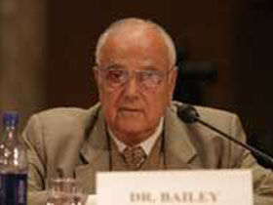
Speaker: Dr. Norman Bailey, adviser of Undersecretary Negroponte. Former Director of Security National Planning, Senior Director of International Economic Issues of the National Security Council and Special Assistant of President Ronald Reagan for international economic policy and in the presidential campaign of vice-president George H.W. Bush; Adviser in Latin American Issues in the presidential campaign of George W. Bush in the 2000; and Associated investigator of the Center for Strategic and International Studies.
Place: American Club
May 26, 2008

- “Case Law and Judicial Efficacy”
Speaker: Hon. Bohdan A. Futey, Judge of the U.S. Court of Federal Claims
Places: American Embassy, Supreme Court of Justice of Argentina, Association of Judges and Judicial Officials of the National Judiciary, Libra Foundation, Austral University, International Judicial Academy, University of Belgrano, and the University of Buenos Aires
July 3rd and 4th, 2008

- “The impact of the Latin electorate in the presidential campaign of 2008”
Speaker: Octavio A. Hinojosa Mier, Executive Director of Congressional Hispanic Leadership Institute (CHLI)
Place: American Embassy
August 6th, 2008

- “Internet, Politics and the U.S. Presidential Elections”
Speaker: Professor Carol Darr, Adjunct Lecturer in Public Policy at Harvard University's John F. Kennedy School of Government and Adjunct Professor at George Washington University.
Place: American Embassy
September 19th, 2008

- “The U.S. Presidential Candidates and their Perspectives”
Speaker: Raúl “Danny” Vargas, chairman of the Republican National Hispanic Assembly.
Place: American Embassy
September 24th, 2008

- “United States, International Security and Nuclear non proliferation”
Speaker: Ambassador Greg Schulte, U.S. Representative to the International Atomic Energy Agency and the UN in Vienna. Former Executive Secretary of the National Security Council of the White House.
Place: Argentine Council for Internacional Relations (CARI)
October 16, 2008

- “The U.S. Presidential Elections, Party Platforms and the Profiles of the Candidates”
Speakers: Susana Mendoza (State Representative of the Democratic Party, Illinois) and Mr. David Rivera (State Representative of the Republican Party, Florida).
Place: American Embassy
October 29, 2008

- “The Inter-American System of Defense: opportunities and challenges”
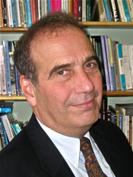
Speaker: Dr. Hal Klepak, special advisor to the Department of National Defence of Canada, the Department of Foreign Affairs and the Army Commander for Latin American security Affairs. Main advisor of the VIII Conference of Defence Ministers of the Americas (CDMA).
Place: Canadian Embassy
November 7, 2008

- “Challenges on Human Rights for the Obama Administration”
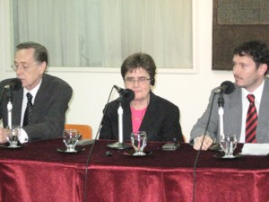
Speaker: Dr. Allida Black, Project Director and Editor of The Eleanor Roosevelt Papers, an initiative destined to preserve, teach and spread the writings and analysis that Eleanor Roosevelt realized in the matter of human rights and democratic policies, and Professor of History and of Public Policy and Public Administration at George Washington University.
Place: CARI
December 9, 2008

- “The Judicial System, the roll of the Judge and the right to the privacy”
Speakers: District Judge (Maryland District) Peter J. Messitte, consultant on judicial reform projects throughout Latin America and Africa, and former member of the International Judicial Relations Committee of the Judicial Conference of the United States; and Dr. Jon L. Mills, Dean Emeritus, Professor of Law and Director of the Center for Governmental Responsibility of the University of Florida (UF), Chair of the Florida Supreme Court Committee on Privacy and Court Records and former Speaker of the House (1987-88), of the Florida House of Representatives (1978 - 88).
Places: American Club and University of Buenos Aires
December 11 and 15, 2008

- "The New Administration, the New Congress and the relations with Latin America"
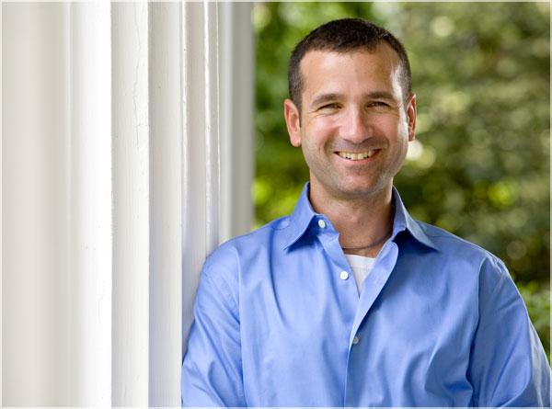
Speaker: Dr. Javier Corrales, professor of Political Science of the Amherst College. Former consultant of the World Bank, United Nations and the American Academy of Arts and Sciences
Place: American Club
April 7, 2009

- Visit of the Sam Nunn School of International Affairs
Speakers: Alejo Espora (Head of Macroeconomic Analysis) and Diego Elías (Main Analyst of Monetary Conjuncture).
Place: BCRA (Central Bank of the Argentine Republic).
May 26, 2009

- Lunch of the Day of Independences
Speaker: Chargé d’ affairs Thomas P. Kelly
Place: American Club
July 7, 2009

- “Arms Control and Non Proliferation under the Obama administration”
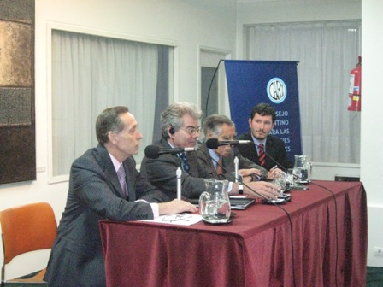
Speaker: Dr. Gary Samore, Special Assistant of President Obama, and White House Coordinator for Arms Control and Weapons of Mass Destruction, Proliferation, and Terrorism.
Place: CARI
August 10, 2009

- “Organization and Financing of Political Campaigns”
Speaker: Dr. Michael Hannahan, professor of Political Science of the University of Massachusetts. Director of the Donahue Institute.
Places: Lebensohn Institute (of the UCR Party), the Hanna Arendt Institute (Civic Coalition Party), the Movimiento Productivo Argentino (formed by representatives of several parties) and the American Club
September 2 and 3, 2009

- “Strengthening the Nuclear Nonproliferation Regime: A Blueprint for Progress”
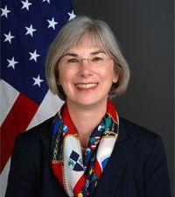
Speaker: Ambassador Susan Burk, Special Representative of the President Obama for Non Proliferation,
Place: University of Belgrano
October 27, 2009
- “The Foreign Policy of the Obama Administration: Strategic Challenges and the Situation in the Middle East”
Speaker: Dr. Jonathan Adelman, professor of the Graduated School in International Studies at the University of Denver.
Places: Association of Leaders of Companies, the CARI, the TESA Foundation and the American Club.
November 4-5, 2009

- “Human Rights and the Foreign Policy of the Obama Administration”
Speaker: David Rieff, specialist in immigration, international conflict, and humanitarianism.
Place: CARI
November 10, 2009

- “Afghanistan, Pakistan and the Middle East: the Challenges of the Foreign Policy of the Obama Administration”
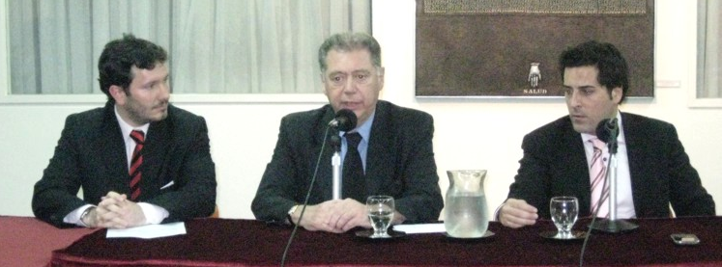
Speaker: Dr. Marco Vicenzino, Director of the Global Strategy Project (GSP) and Chief Strategic Advisor of the Afghanistan World Foundation.
Place: CARI
December 9, 2009

- “The cultural affirmation of the Afro-American populations”
Speaker: Dr. Ana Lucia Araujo, Professor of History of the Howard University
Place: Embassy of the United States
February 24, 2010

- “Civil Military Relations in a Democracy”
Speakers: Dr. Thomas Bruneau and Major General Richard B. Goetze, Jr., USAF (Ret.., former Vice Director of the Joint Chiefs of Staff). Program for Latin America of the Center for Civil–Military Relations (CCMR) in Monterrey, California.
Place: American Club and CARI
April 13 and 15, 2010

- “Alternative Energy and Climate Change”
Program organized for 10 specialists, with the support of the State Department and the Embassy of the United States in Argentina.
Places: Washington DC, Des Moines (Iowa), Sprinfield (Illinois) and Austin (Texas).
June 14-22, 2010

- “Regimes and policies on greenhouse control in the USA and their legal aspects”
Speaker: Dr. Luis Martinez, attorney with the Natural Resources Defense Council’s energy program.
Place: American Club
June 25, 2010

- “Key Components of an energy security policy in emerging countries”
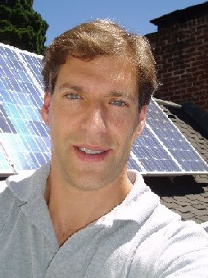
Speaker: Dr. Daniel Kammen, adviser of the Obama Administration in issues of climate change, co-director of the Institute of Environment of Berkeley and a coordinating lead author for the Intergovernmental Panel on Climate Change
Place: American Club and CARI
July 14 and 15, 2010

- “Participation of the Community in the Service of Justice and Programs of Domestic Violence”
Speaker: Liberty Aldrich, Director, Domestic Violence & Family Court Programs, Center for Court Innovation.
Place: American Club
September 15, 2010

- “Reflections on Reagan: the person and his presidency in an historical perspective”
Speaker: Dr. Michael Flamm, professor of History in Ohio Wesleyan University.
Place: American Embassy
February 22, 2011

- “Abraham Lincoln in 2011: his legacy today”
Speaker: Dr. Ronald White, author of the book “A. Lincoln: A Biography” (2009). PhD in Princeton University and professor of the UCLA, Princeton Theological Seminary, Whitworth University, and Colorado College.
Place: American Embassy
March 16, 2011

- “The New Latino Electorate of the United States in the 2012 Elections and Beyond”
Speaker: Dr. Henry Flores, Dean of the Graduate School at St. Mary's University (San Antonio, Texas).
Place: CARI
March 23, 2011

- “The formation of Barack Obama: the President and his policies in an historical context”
Speaker: Thomas Sugrue, professor of History and Psychology at the University of Pennsylvania.
Place: Embassy of the USA in Argentina
August 25, 2011

- “Think the future: Scenarios for Latin America 2030”
Speakers: Héctor Casanueva Ojeda. Executive Director of the Latin-American Center for the Relations with Europe. Former Director of ProChile (1997-2000), Ambassador of Chile to the ALADI and the Mercosur (2000-2005), and International Affairs Director of the Agriculture Ministry (2009-2010).
Miguel Ángel Gutiérrez. Director of the Latin-American Center of Globalization and Prospective, professor and consultant in International affairs in several International and national universities.
Place: American Club.
September 12, 2011

- “Government 2.0”
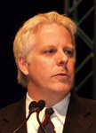
Speaker: Lewis Shepherd, Director of the Microsoft Institute for Advanced Technology in Government.
Places: CARI, the National Technological University, the National University of La Plata, the Inter-American Open University (Rosary branch), the Argentine Business University and the IX International Congress on Informative Technological Innovation.
September 19-23, 2011

- “The Impact of the Communications: How To construct a Successful Political Campaign”
Speaker: Marcela M. Berland, president of LatinInsights and expert in strategic communications, specialized in the Hispanic market of the USA and Latin America.
Place: American Club
November 3, 2011

- “The Leaders of Tomorrow”
Speakers: local representatives of the initiative “Teaching for All”.
Place: American Club
December 1, 2011

- “The State of the future 2011: future scenes for the governance and energy"
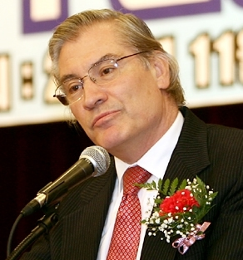
Speaker: Jerome Glenn, founder and director of the Millenium Project. Has over 35 years of Futures Research experience working for governments, international organizations, and private industry in many fields.
Place: American Club
December 7, 2011

- “Present and future of the bilateral relation”
Speaker: Jorge Arguello, Ambassador of Argentina towards the United States
Place: American Club
June 26, 2012

- “Elections 2012: Program in Argentina”
Speaker: Jennie Lincoln, professor of the Sam Nunn School for International Affaires (Georgia Tech).
Places: National Legislators Circle, National University of Rosario, National University of La Plata, National University of Buenos Aires, Argentine Catholic University, Catholic University of La Plata, Buenos Aires Province Senate, Buenos Aires City Legislature, American Club, Argentine Council for International Relations, AMCHAM,
September 10-14, 2012

- “Elections 2012: Program in the United States”
Places: National Democratic Institute, National Republican Committee, National Defense University, Inter-American Dialogue, White House, U.S. Congress, Supreme Court, State Department, Department of Commerce, Washington City Hall, Robert Kennedy Center for Justice and Human Rights, AMCHAM, Argentine Embassy, polling stations in Fairfax, Falls Church and Arlington, Washington Times.
November 4-9, 2012

- “Workshop on Exports Control of dual use technologies”
Speakers: representatives from the Justice Department of the United States and from the Federal Bureau of Investigation (FBI).
Place: Club Americano
November 14 y 15, 2012

- “Conclusions on the U.S. election: perspectives in general and Hispanic weight and growing phenomenon”
Speaker: Marcela Berland, President and CEO of LatinInsights.
Location: American Club
November 30, 2012

- “Borges and American Literature”
Speaker: Silvia Zimmerman Castle, disciple and collaborator of Jorge Luis Borges, author and Executive Director of the Club of Rome – Argentine Chapter.
Location: American Club
April 23, 2013

- “Political Campaigns and Social Media”
Speaker: Juan Proaño, co-founder and CEO of Plus Three.
Places: Argentina Catholic University Circle Legislators, Senate of the Province of Buenos Aires, “El Día” Newspaper, American Club.
August 27, 2013

- “Relations between the United States and Latin America”
Speaker: Dr. William C. Smith, professor at the University of Miami.
Places: Argentina Catholic University Circle Legislators, Senate of the Province of Buenos Aires, “El Día” Newspaper, American Club.
November 18 and 20, 2013

- “American political outlook from a Latino perspective”
Speaker: Fabian Bedne, Council Member for the city of Nashville, Tennessee.
Place: American Club.
February 20, 2014

- “School Climate and Violence ("Bullying")”
Speaker: Professor Richard Cardillo, educational director of the National School Climate Center (NSCC).
Location: Catholic University of Argentina
April 24, 2014

- “John Fitzgerald Kennedy in history and memory”
Speaker: Dr. Michael Flamm, professor of U.S. History at Ohio Wesleyan University.
Location: Argentine Council for International Relations (CARI)
May 20, 2014

- “Political campaigns and midterm elections in the United States”
Speaker: Daniel DiSalvo, senior fellow at the Manhattan Institute's Center for State and Local Leadership and Professor of Political Science at The City College of New York.
Location: American Club
May 26, 2014

- “Justice Community Centers”
Speakers: Alex Calabrese, New York State Acting Supreme Court Justice and Presiding Judge for the Red Hook Community Justice Center in Brooklyn, New York, and Mr. Julius Lang, Director of Technical Assistance at the Center for Court Innovation.
Location: American Club
May 28, 2014

- “U.S. Foreign Policy and Anti-Americanism”
Speaker: Professor Max Paul Friedman (American University).
Location: Catholic University of Argentina (UCA)
June 4, 2014

- “Latin America in Comparative Perspective”
Speaker: Dr. Richard Snyder, Director of the Center for Latin American and Caribbean Studies, and professor in Brown's Department of Political Science.
Location: American Club
July 3, 2014

- "Teaching Law in Argentina and the U.S.A.: Comparative Experiences"
Speaker: Dr. Alejandro Garro, Adjunct Professor at the Columbia Law School of the Columbia University.
Location: American Club
August 14, 2014

- “The American Presidentialism and separation of powers"
Speaker: Dr. Bert A. Rockman, professor of Political Science at Purdue University (Illinois).
Locations: Catholic University of Argentina (UCA) and American Club
October 6, 2014

- “Judicial System of the United States”
Places: Department of Justice, Department of State, DEA (Drug Enforcement Agency), Federal Judicial Center, U.S.A. Court on Federal Claims, Administrative Office of the Courts of the United States, National Center for State Courts, the International Association for Court Administration, the Center for Court Innovation, Universities (Georgetown and Columbia), Argentine Embassy to the United States and the Organization of American States, Argentine consulate in NY, etc.
October 27-31st, 2014

- “Election 2014: Program in the US”
Places: International Republican Institute, Democratic National Committee, National Defense University, Inter-American Defense College, Inter-American Dialogue, United States Congress, Departments of State, Defense, Commerce and Justice, City Legislature of Washington, Robert Kennedy Center for Justice and Human Rights, Embassy of Argentina, polling stations in Virginia, etc.
November 2nd-7th, 2014

- “The Latino vote in 2016”
Speaker: Dr. Mark Hugo Lopez, Director of Hispanic Research at the Pew Research Center.
Location: American Club
November 13, 2014

- “Situation in matters of cooperation and hemispheric security”
Speaker: Admiral Martha Herb, Director of the Inter-American Defense College
Location: American Club
April 13, 2015

- “Traffic of Drugs and People in the US"
Speaker: Deputy Attorney Elizabeth Rabe, qualified in the Northern District of New York, bordering Canada, and previously for four years in the city of Laredo, Texas, Mexico border.
Location: American Club.
August 13, 2015

- “The importance of Open Government and citizen participation in a strong democracy”
Speaker: John Wonderlich, one of the leading advocates and experts on open government and transparency policy of the United States
Place: American Club.
September 22, 2015

- “US election from a Democratic and Republican youth perspective”
Speakers: Adryana Boyne (consultant, analyst and public policy, corporate marketing and Hispanic Affairs strategist with PIC (Public Integrated Communications). National Director of VOICES Action, an organization that informs and educates Latinos on public policy) and Alejandra Salinas (former National President of the College Democrats of America, the official youth branch of the Democratic Party. Alejandra is the first president member of the Hispanic community and the youngest person to hold this position, in the eighty years of the organization).
Place: American Club.
May 3, 2016

- “US Elections”
Speaker: Carlos Waisman (Professor at the University of San Diego, California).
Place: American Club
May 12, 2016

- “US election and its impact on foreign policy, from the Democratic and Republican perspective”
Speakers: Peter Quilter (Senior Researcher at the Ash Center for Innovation and Democratic Governance of the Kennedy School of Harvard University, former Policy Advisor on Latin America to the presidential campaigns of Obama, and previously for John Kerry) and Daniel W. Fisk (Director of Operations at the International Republican Institute, former Special Assistant to President George W. Bush and Director for the Western Hemisphere at the National Security Council (2005-2009)).
Place: American Club
June 30, 2016

