Lewis Shepherd
Microsoft Institute for Advanced Technology in Governments
12012 Sunset Hills Road, Reston, VA 20190
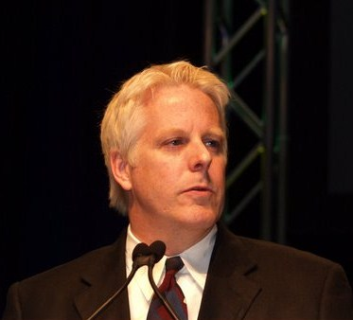
Office: (703) 673-7826
Mobile: (202) 306-3024
Fax: (703) 673-7659
lewiss@microsoft.com (email)
www.ShepherdsPi.com (blog)

Biography
Lewis Shepherd is Director of the Microsoft Institute for Advanced Technology in Governments (MSI). He joined Microsoft in 2007 after nearly five years in the U.S. Department of Defense, where he served in the Senior Executive Service. Lewis has degrees from Stanford University (where he was a Rockefeller Doctoral Fellow in the Political Science Department), the University of Virginia, and the Université Libre de Bruxelles (Belgium). He has also been a guest-lecturer at the Stanford Graduate School of Business.
Lewis spent two decades working in and around Silicon Valley, but after the 9/11 attacks he moved to Washington DC and focused on government technologies to support information sharing and reform for the Global War on Terror. Some of his team's work focused on cyber-security, better intelligence analysis, and introducing Web 2.0 capabilities to government networks.
Today his Microsoft Institute staff is composed of senior technologists with experience in the technology industry and in local, regional, national, and international government at all levels. The Microsoft Institute focuses on major enterprise-wide problems of national governments, but also works with state and local governments and homeland security organizations in areas including national security, counterterrorism, e-government, health care, and education. The Institute represents Microsoft’s commitment to innovation in these areas using the cutting-edge technologies being developed in Microsoft’s world-class research organization, including work on natural user interfaces, speech and gesture recognition, social collaboration, robotics, supercomputers, and cloud computing.

